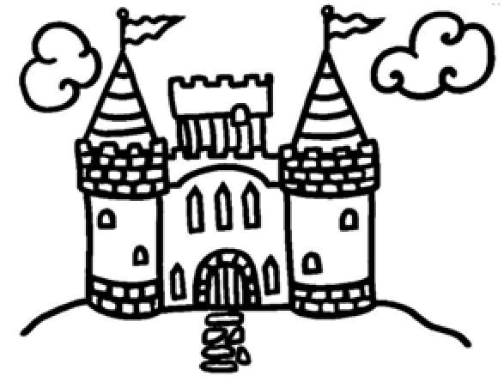
Kid’s Kastle Now Hiring!!
*Extra Spending $$
*Flexible Scheduling
*Monday-Friday
*After school hours
*Closed Major Holidays
*Scholarship Opportunities Available
*Must be 18 Years Old
(A+ Clock hour tutoring Credit for volunteers & students under 18 Available)
Kids Kastle is a family owned, licensed childcare center for children newborn – 12 years old. We are looking to hire motivated individuals passionate about working with children who are ready to go the extra mile to make every child feel special. If you are ready for an exciting School year where the fun never ends and the learning never stops, Please Call (314) 892-2004
We look forward to hearing from you soon!

